**CloudLogDHT11 Tutorial**

Step 1: Download MongoDB

<https://www.mongodb.com/download-center>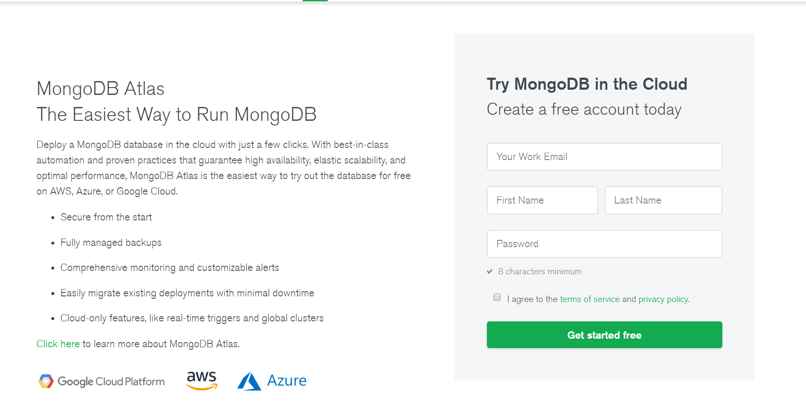

Step 2: Go to the launch-wizard in the Security Groups and change the source to My IP

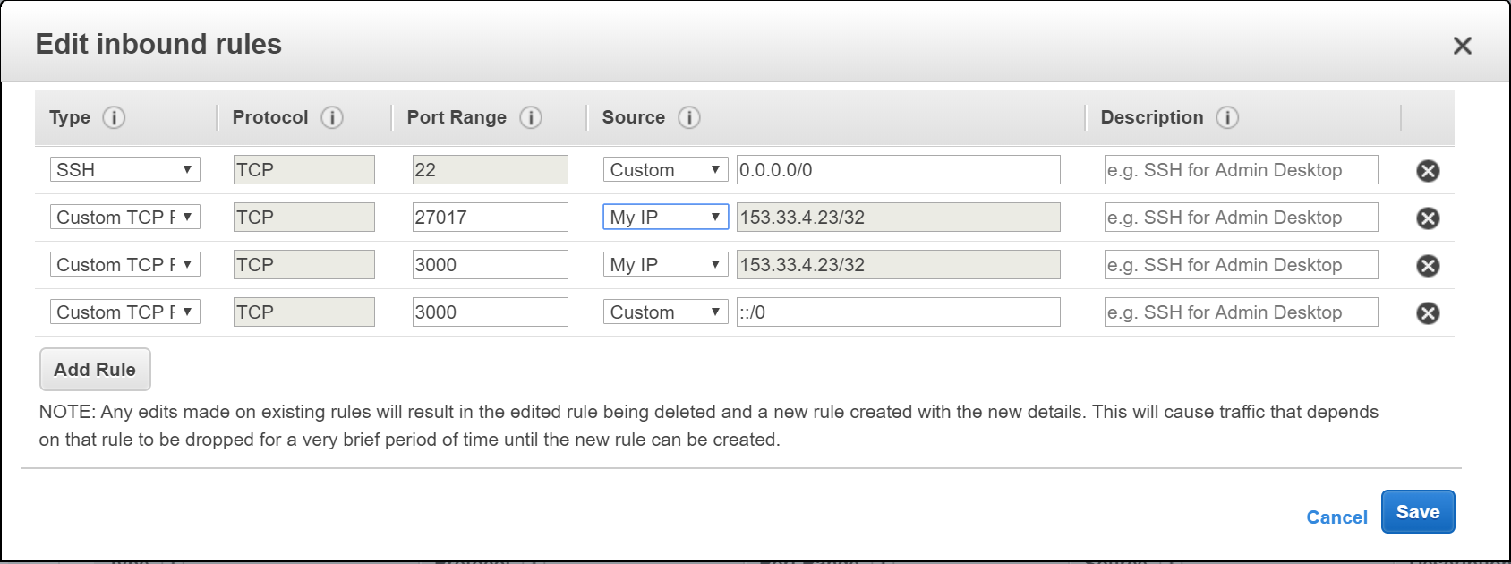

Step 3: Connect MongoDB to host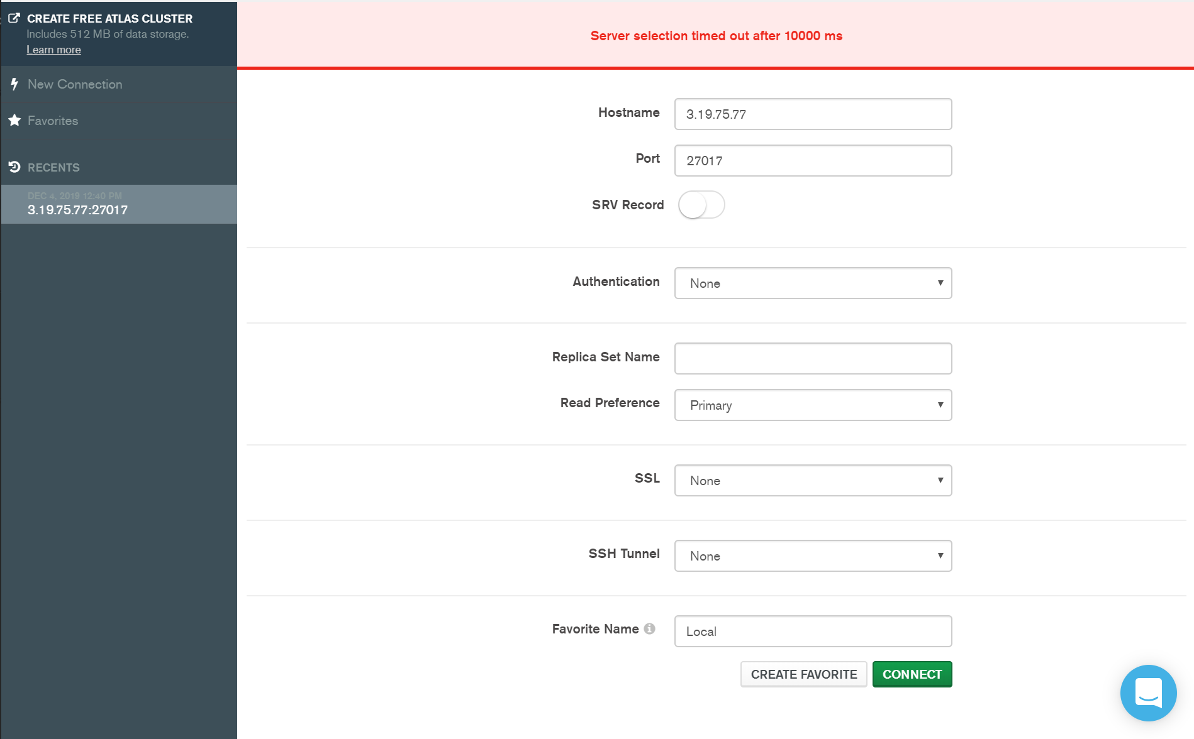

Step 4: Run the virtual machine by sshing into Ubuntu



Step 4: Cd into the cloudLogDHT11 folder and run ‘node server.js’

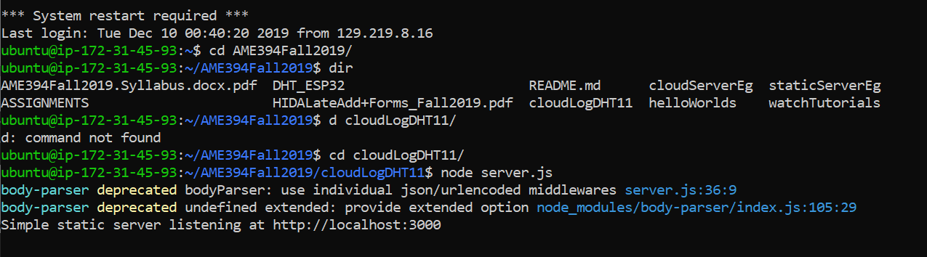

Step 6: Run DHT11Default.ino on the watch and connect the watch to a hotspot

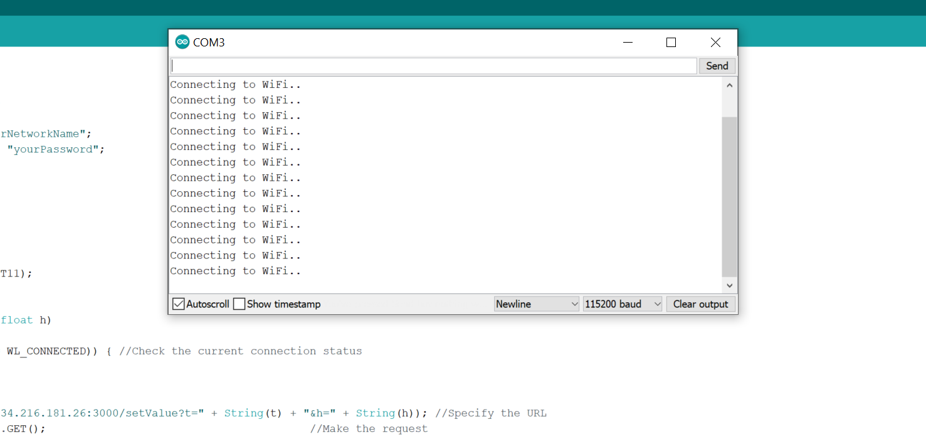

Step 5: Visit the IP address and get the value

